How to waitlist a class:
If you are using the Class Search function, please read all Steps. If you have added the class via a class number or MyScheduler straight to your Shopping Cart, please skip to Step 3.
Important Rules of Waitlisting a Course:
- Please ensure you have space available in your schedule for the waitlisted class to be added. As you can take a maximum of 18 credits in most cases, please ensure that you would not go over 18 credits if the course was added. If the class being added would take you over 18 credits, you will never be able to be added to this course automatically from the waitlist.
- Please ensure that the class you are waitlisting does not have a time conflict with another course you are enrolled into. If it does, you will never be able to be added to this course automatically from the waitlist.
- Please ensure you have no enrollment holds on your account. If you do, this may impede your ability to be added off of the waitlist automatically.
- If you are waitlisting a second section of a class you are already enrolled into, you will never be added to this second section. Example: if you are wanting to take the online section of ECON 202, please do not enroll into the in-person section of ECON 202. The system is not smart enough to know which section you prefer, and so you will remain on the waitlist for the second section.

Step 1: Searching for a waitlisted class.
In the Class Search, ensure you have UNCHECKED the Show Open Classes Only Box to allow waitlisted classes to be searched for. If you do not uncheck this box and there are no open sections, you will receive the “The Search Returns No Results That Match the Criteria Specified” error.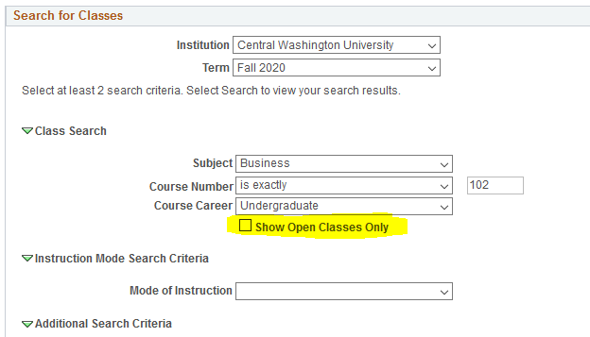

Step 2: Finding the waitlisted class.
All waitlisted classes are indicated with a yellow triangle. They can be selected like any other class and added to your Shopping Cart.
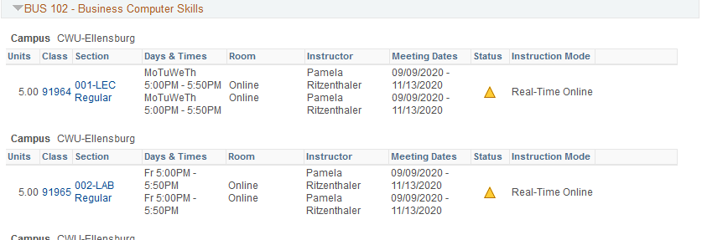

Step 3: Adding the waitlisted class to your shopping cart.
In order to waitlist a class, you will need to indicate that you are aware it needs to be waitlisted and are okay with being placed on the waitlist. You can do so by clicking the box labeled “Waitlist if Class is Full”. If you do not click this button, you cannot be placed on the waitlist.
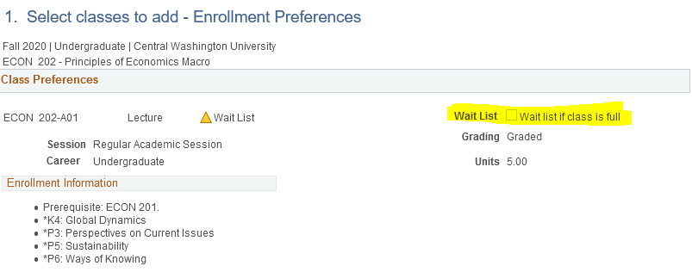

Step 4: Enrolling into the course
You will enroll into a waitlisted class like any other course at this point. Please proceed to Step 2 of 3, confirm your courses, and then finalize your Enrollment.
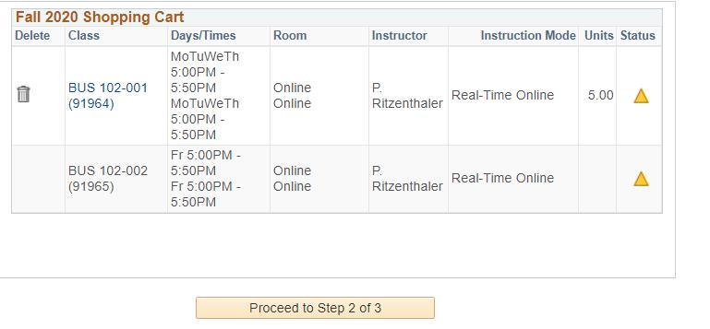

Step 5: Confirming your Enrollment
Once your enrollment is finalized, you should see a confirmation that you have been placed on the waitlist. You will also see what position you have been placed on the waitlist.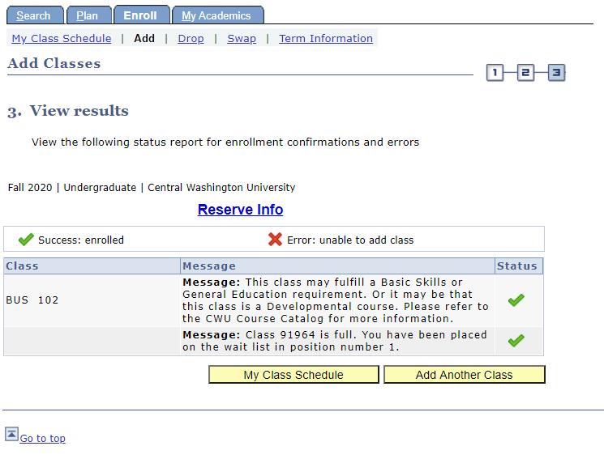
If you have any questions about the waitlisting of a College of Business course, please email your advisor or call 509.963.2930.

