How to Read My Academic Requirements Report
- Log into MyCWU account.
- On the left hand side of the MyCWU homepage under My Profile, click on the link “Visit Your Student Center
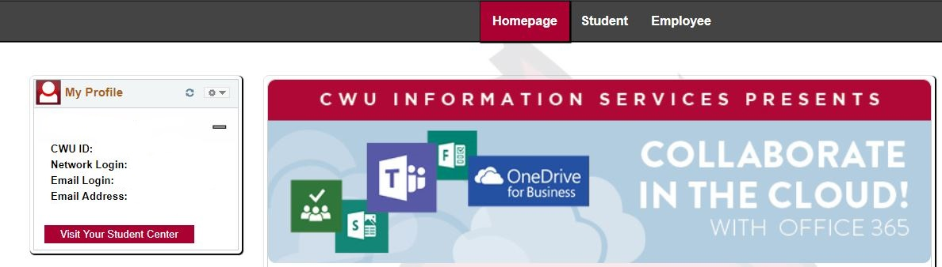
- Click the drop down menu on the left hand side underneath academics. Then click on “Academic Requirements” and click the arrows to open it
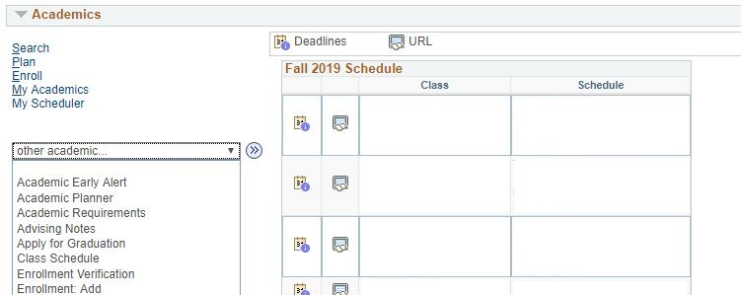
- Click “Expand All.”
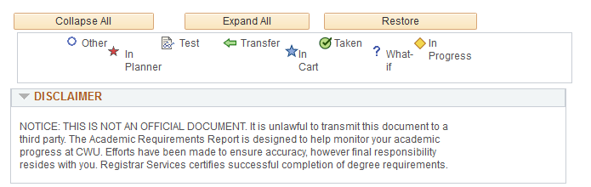

- Under the “Undergrad Degree Requirements” section, take a look at the number of credits taken and the number of credits needed out of the 180 total credits required. This is important because all students need at least 180 credits to graduate.
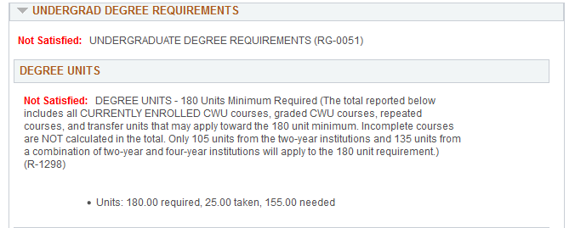
Consider number of credits needed to meet the 180 credit rule.

Note: This report includes all classes you are currently registered into.

- Also notice that students need to complete 60 upper-division units. This means that at least 60 out of the 180 credits needed to graduate will need to be 300-400 level classes.
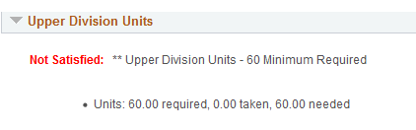
- Under the “GPA Requirements” section, there should be two GPAs given:

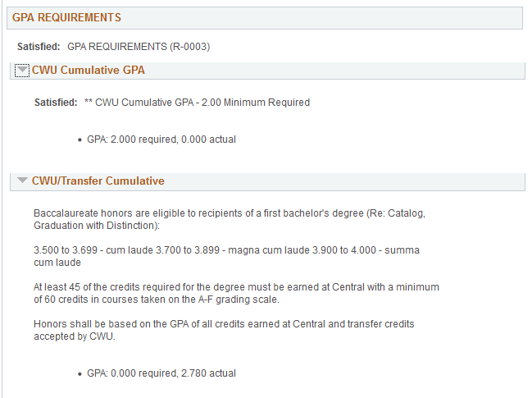
2) CWU/Transfer Combined GPA is your collegiate GPA.

1) CWU Cumulative GPA is comprised of CWU GPA only, excluding all transfer GPAs (minimum 2.00 GPA requirement).

- Do you have the first two-years of a four-year degree complete?

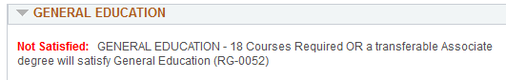

- Next, scroll down to the “General Electives” section. These classes are counting towards your 180 credits for graduation but are NOT counting within your major, minor, or general education. 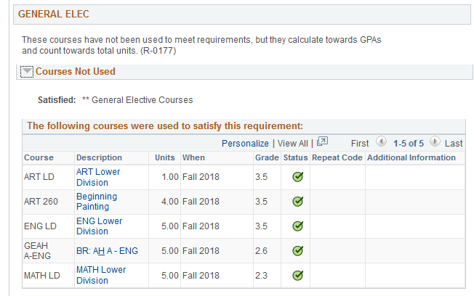

- If you are a PRE-MAJOR: Under the “Pre-Bus Admin” section is where you will find if all of your Pre Admission Business Requirements are met. This includes the 9 courses totaling to 43 credits. Once you are fully-admitted, the rest of your major requirements will be on your AR report.
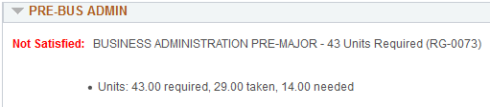
- Next look at the “Pre-Business GPA” section to find your cumulative GPA for the pre-admission courses. 2.5 GPA minimum requirement.
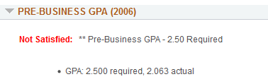
Pre-Business GPA required for ADMISSION into College of Business Program.
- ADMITTANCE INTO PROGRAM: When accepted into the major, look at the number of credits taken and the credits needed.
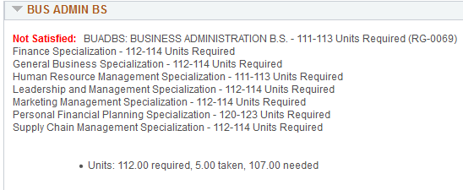
Consider number of credits needed to meet the credit requirements for each specialization.

- Look at the “Bus Admin GPA” section to find your cumulative GPA for all business courses, both pre-admission courses and in the major courses. Look at the “Bus Admin UD GPA” section to find your cumulative GPA in all of your 300 and 400 level business courses. Minimum 2.25 GPA required for both to graduate.
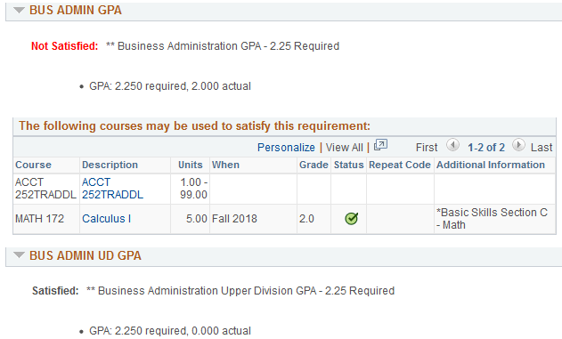
Business Administration Upper Division GPA required.
Business Administration GPA required.

REMEMBER THE 4 GPAS REQUIRED FOR GRADUATION:
- CWU Cumulative GPA
- CWU/Transfer Combined GPA
In major GPAS:
- Major GPA
- Upper Division GPA
There may be additional GPAs needed for graduation, based upon major program. Please speak with your advisor, or consult the catalog for these.

