Turnitin Quick Submit Option

*You must create a Turnitin assignment in Canvas to set-up your Turnitin account BEFORE you can use the Quick Submit option.

Faculty can use the Quick Submit feature to check a student submission that wasn’t part of a a Turnitin Canvas assisgnment by logging into Turnitin.com directly.

Follow these steps to use the Quick Submit feature:
- Create a password at Turnitin.com using your CWU first.last@cwu.edu email address as the username.
- Update User Info Settings by activating the Quick Submit feature
- Submit document for plagiarism detection

Here are some screenshots of the step-by-step process.
- Go to https://turnitin.com and click on the ‘Log In’ option in upper right-hand corner.

- Select the ‘Reset Password’ option
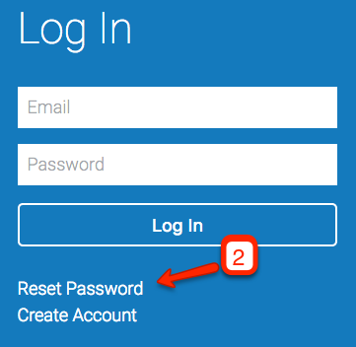

- Enter first.last@cwu.edu email address
- Enter Last name
- Click ‘Next’

You will receive an email with instructions on how to create a password. Once you have created a password, use the CWU email (first.last@cwu.edu) and the new password you created to login to https://turnitin.com

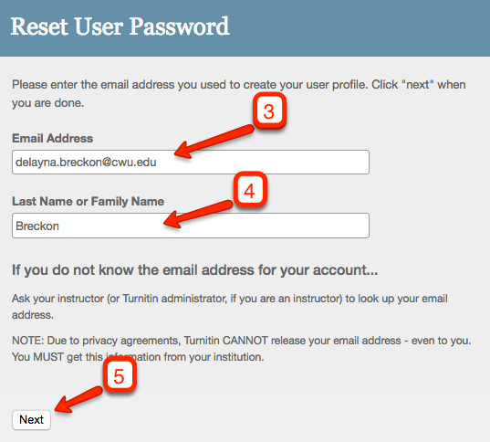

- Select ‘Instructor’ view from the drop-down menu
- Click on ‘User Info’
- Select ‘Yes’ from the Activate Quick Submit drop-down menu
- Click ‘Submit’
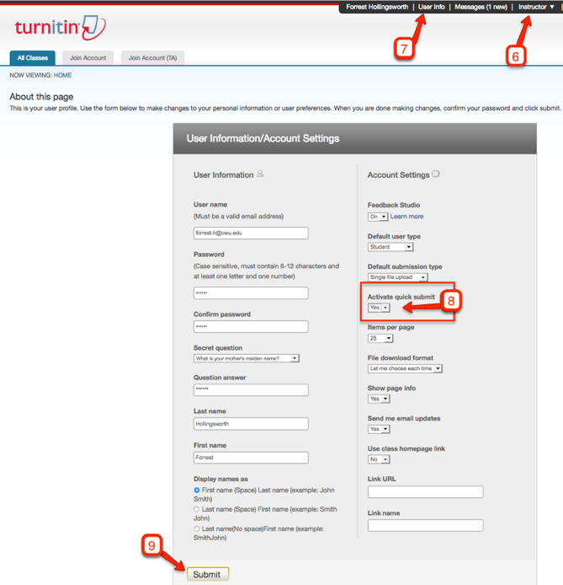

- Click the ‘Quick Submit’ tab
- Click the ‘Submit’ button and follow the instructions for uploading the document.

