How-To Install Flipgrid in CWU Canvas
- Go to https://info.flipgrid.com/ and click Sign up (upper right corner)
- Select Sign up with Microsoft and use your CWU credentials (username@cwu.edu)

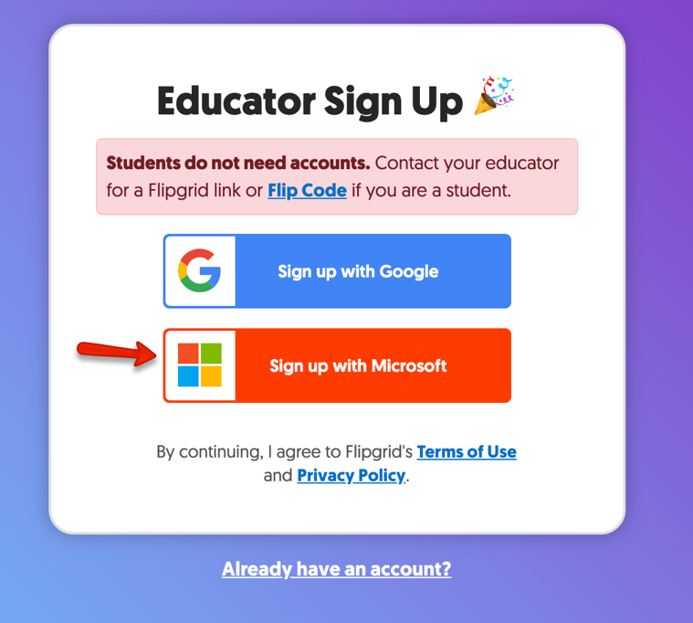

- After creating your account go to your profile in the upper right corner and select

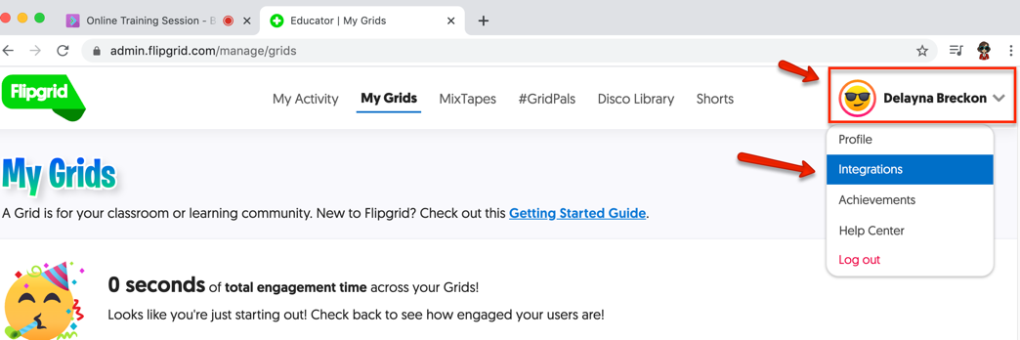

- Select the ‘Add new integration’ button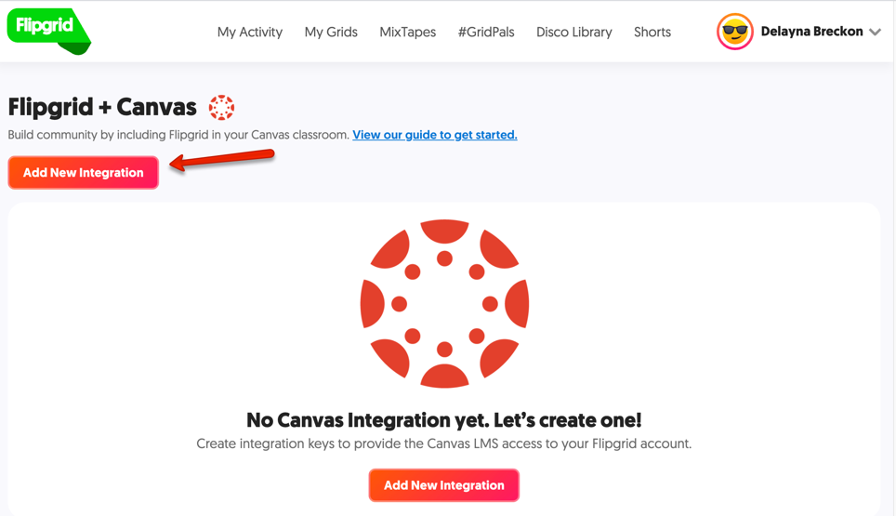

- Name the integration CWU Canvas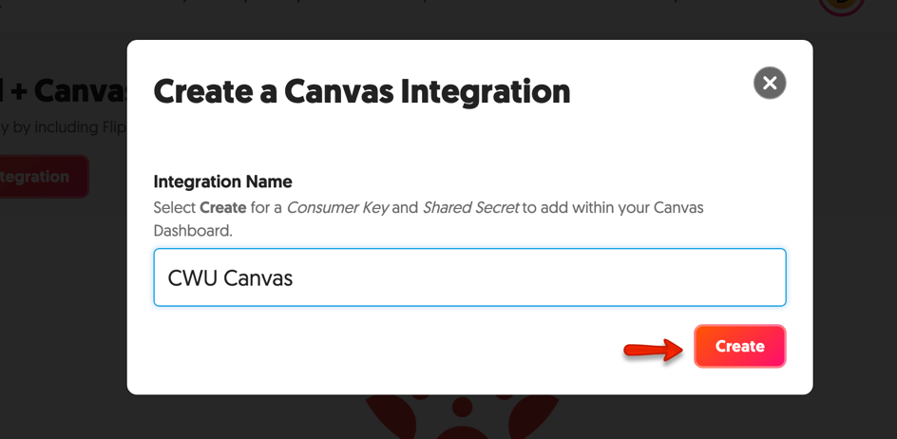

- This will create a Consumer Key and Shared Secret unique for your account. You will need these to add Flipgrid to your Canvas course.

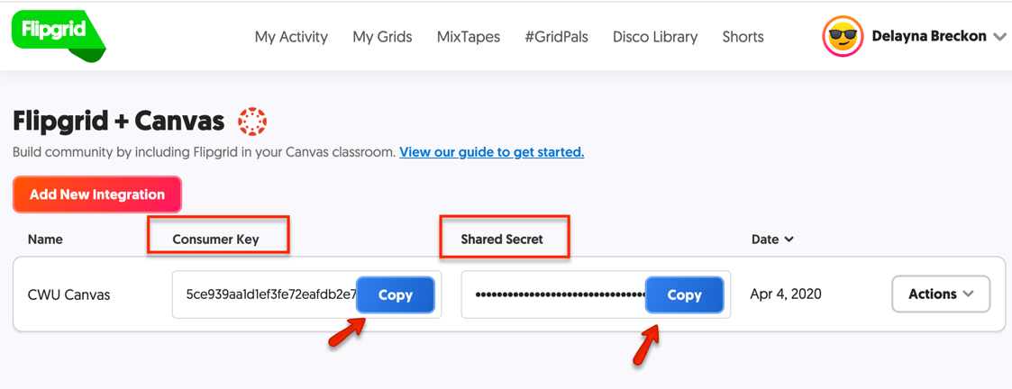

- Login to https://canvas.cwu.edu and navigate to the course you want to add Flipgrid to.
- Select ‘Settings’ from the navigation menu
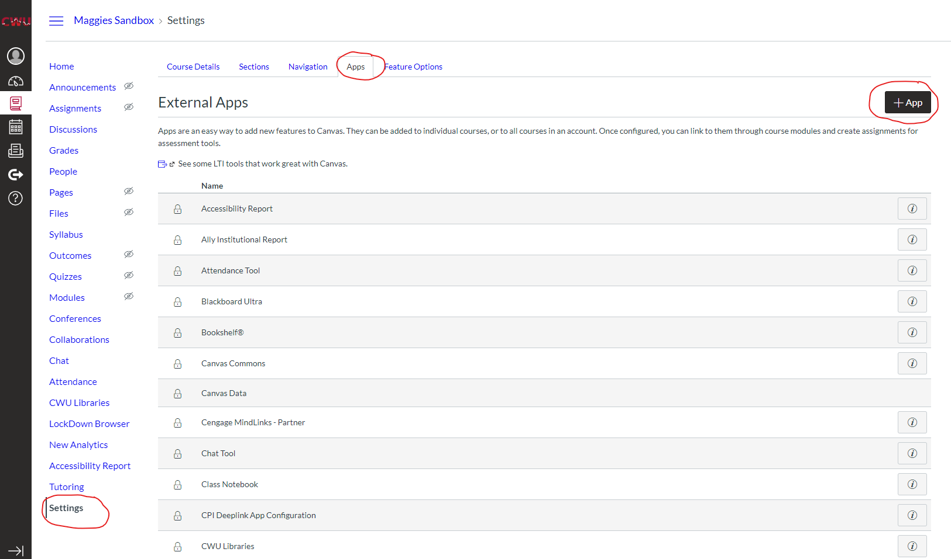
- Select ‘Apps’ from the tabs along the top and then +APP

- To Add the App
  - Configuration Type = By URL
  - Name = Flipgrid
  - Consumer Key = paste from step 7
  - Shared Secret = paste from step 7
  - Config URL =https://static.flipgrid.com/source/canvas/flipgrid_canvas.xml

