Creating OneNote Class Notebooks in Canvas

There are advantages to using OneNote class notebook from within Canvas. Probably the biggest advantage is that once you create a class notebook for a course, students will be automatically enrolled in the notebook as they sign in to the class. If you create the notebook from outside of Canvas you will not have this option.
To create a class notebook, open your course in Canvas follow the steps below. If you do not currently have an active class, open your Sandbox in Canvas.

- Go to your course Settings
- Select the ‘Navigation’ tab
- Drag the ‘Class Notebook’ option to your active links.
- Click ‘Save’ at the bottom of page

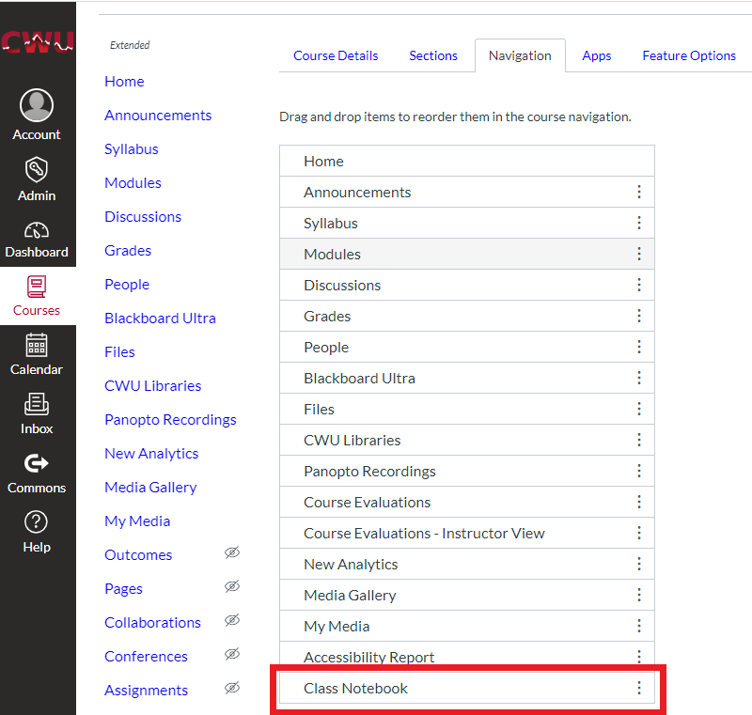

- Select Class Notebook from left hand side Canvas menu
(If the Class Notebook option is not visible you need to click on Settings then on the Navigation tab and enable Class Notebook up to the active links list, then Save)

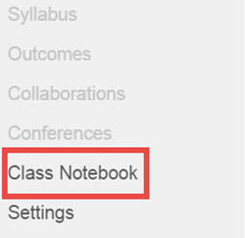
- Select ‘Sign in to OneNote’.
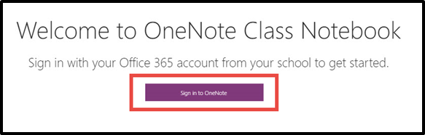
- Once you enter your full CWU email address, (username@cwu.edu) you will be redirected to a different page to sign in. If you are already logged into other Office 365 applications already, it should log you in automatically.
- Sign in using full CWU email address (username@cwu.edu) and password on the page to which you were redirected.
- Enter a name for your class Notebook. Your Canvas course name will auto populate the field. However, you may change it if desired. Press Next when finished.
Notes: Good practice is to add your last name to the end of your course name.
Notebooks are not broken up by class periods. Ex. If you are an Algebra teacher, you would create one notebook for all of your algebra classes through this notebook creator.

- The next page gives an explanation of what will be created. There is nothing to do here, so click the Next button.
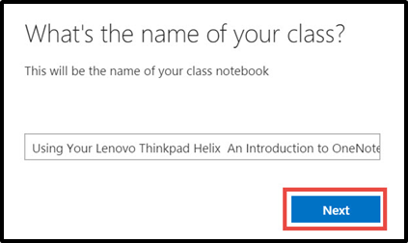
*Optional* If additional teachers need to be added, enter their CWU email addresses into the text bar. Press Next when all collaborating teachers are entered. (They will have the same capabilities that you have.)
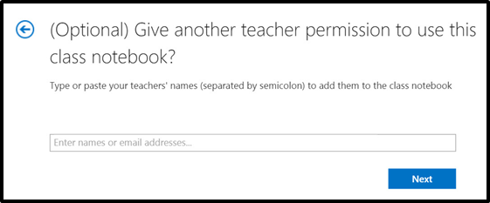

- Select the Automatically add students from your LMS option.

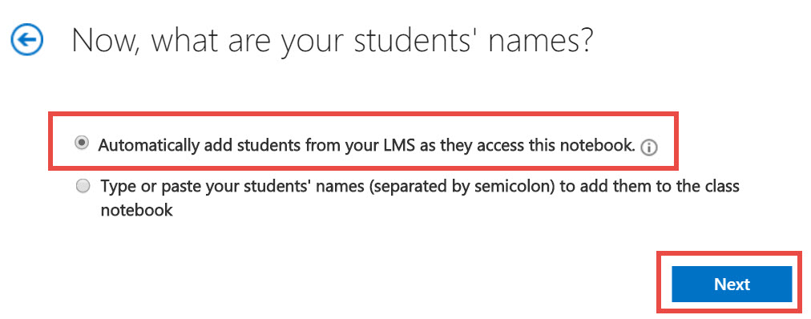

- This page allows you to choose the section tabs in your class notebook. Uncheck any that you do not want. Click Add more to add more section tabs.

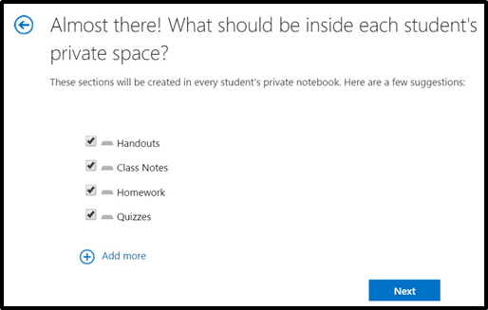

- The last page gives you a quick look at what your notebook will look like. If you have no other changes to make click the Create button and your notebook will be made.

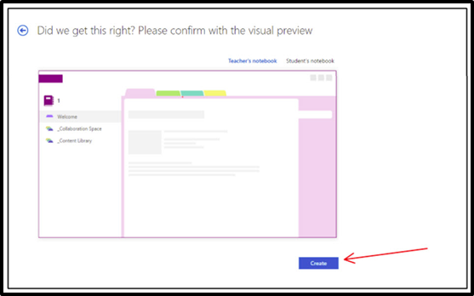

- Click the Open in OneNote to open your notebook in the desktop version of OneNote. It may take a few minutes to completely sync. We recommend that faculty download OneNote App from CWU O365 and use the desktop version to set-up the Notebooks ad it allows for more formatting options. Students can usually just use the Online version to add content.
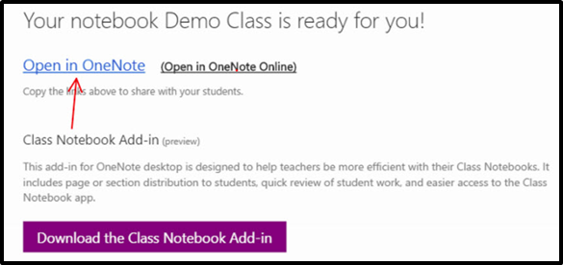
- Note: Once you have opened your Notebook in OneNote, you will not need to access your Notebook through Canvas again. You can go straight to OneNote to access your Class Notebook.

- Now that you have created your class notebook, if you click on the Class Notebook link in your Canvas course, this is the screen that will display. This has options for you to create a new notebook, add teachers, add students, and access notebook links.
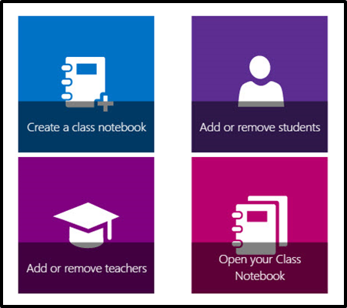
Important Note: Usually you will not create another new class notebook, unless you want your students to connect to a different notebook from the one you have already created.

